In my opinion there is no real substitute for hands-on learning. That is why I signed up for the Karibu Kenya: Culture and Agriculture in Africa class. I had no experience traveling internationally, nor any real knowledge of what to find in Kenya. Unlike many of my fellow students along for the trip, I didn’t have a background in sustainable or bio-intensive agriculture or in plant science. But what I came away with was a better understanding of small scale agriculture, sustainable practices, and a variety of techniques that could be just as applicable in America or on my family’s ranch as they were in Kenya.
We visited a broad range of farms and ranches, schools, and commercial operations that represented some of Kenya’s major agricultural industries. Our first stop was the prison on the outskirts of Nairobi. The program’s motto was, “Kurekebisha Na Haki” in Swahili, or “To Repair with Justice” in English. It highlighted several techniques that we would see incorporated throughout the next few days. The program was designed to help the boys at the school learn a skill that would make them valuable to their community after their sentence was up. By being useful, they could better overcome the social connotations associated with being a former prisoner and lower their chances of ending up back in jail. The boys were allowed to pick which area they wanted to learn about, ranging from agriculture to computers. We were shown how the boys make tea manure, a liquid fertilizer, by placing a bag of manure in a barrel of water and allowing it to steep for a week or so, after which it was diluted to 1/5 strength before application. This process removed the nitrogen from the manure and allowed for easier application to crops. The boys were also being taught the basics of vertical farming. With a bag full of soil, lettuce could grow out of the top as well as the sides where holes had been made. This technique allowed the boys to incorporate agriculture into their practices even in an urban setting.
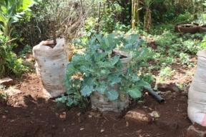

From the prison we moved to the Grow Bio-intensive Agriculture Center of Kenya (GBIACK). The GBIACK was also implementing some powerful programs to help local farmers. Their monthly meetings were drawing in over one hundred farmers who wanted to learn better farming practices—it was nearly as impressive that they fit that many people into such a small room. The center was helping families get a start in meat production through their rabbit giveaway. The center gave away two rabbits for the children to breed, and once the first litter was born the children returned four to the center. Rabbits are a great source of protein; they require little food or inputs, and little labor. The GBIACK also had a similar program with dairy goats. Their goal was to reach everyone in the community—men, women, children, farmers and ranchers. Many places still had the idea that the men were in control but the GBIACK wanted everyone to learn these techniques. The GBIACK was also trying to back up their techniques (double-digging, crop rotation, etc.) with some science and research. They tried corn, corn following soybeans, and soybeans and corn growing together. Their results were mixed, probably because of the mesquite plant (a nitrogen fixer) growing in the center of the test plot. The GBIACK was trying to show that conventional methods of farming weren’t as efficient as they could be, nor feasible in the long run. They showed the farmers how to collect natural seeds for the next season. The fifty bed technique was intended to promote crop diversification, apparently a new idea in Kenya. It was designed so a family would plant a variety of crops to feed themselves for a year and raise a cash crop to buy the items they couldn’t raise like shoes or gasoline. By planting 60% carbon crops, like sorghum, maize, sunflowers, millet; 30% root crops like cassava, carrots, sweet potatoes, onions, or garlic; and 10% cash crops like spinach, kale, cabbage, or tomatoes, a family can ensure that they will have good prices at market if they need to sell/buy anything and have enough food to eat through the year.
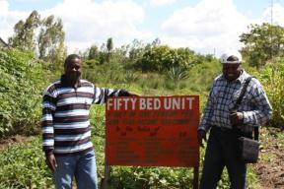

The COSDEP (Community Sustainable Development Empowerment Program) was started by a GBIACK graduate. He was doing very well for himself and his operation seemed to be quite successful. He had more chickens at the center than we saw anywhere else, with over 900. He had ten dairy cows. They were feeding them some sort of roughage that was similar to a Sudan grass, except much taller. It seemed that it wouldn’t have the nutritional requirements for most dairy cattle, but apparently it was working. Like the other sustainable agriculture centers we went to, they used compost in their crop beds. The COSDEP, however, used a technique that recycled the water for the compost, which was unique to this center. They placed the compost on a sloped cement pad. At the bottom was a collection tank. The water was recycled and sprayed again on each stage of composting material as needed. Another trait that made this learning center unique was the mushroom growing. I hadn’t seen any commercial mushroom production before. It was a very interesting procedure. We were shown how to inoculate some of the spores and get them ready to grow. The mushrooms grew off of the materials in plastic bags inside a dark shed. They said that the mushrooms were a very valuable cash crop. They grew lettuce, tubers, and some other vegetables as well. The COSDEP’s goal was to show the farmers that sustainable agriculture was feasible. I think that one of the biggest hindrances sustainable agriculture was facing in Kenya was awareness and communication. The techniques most agriculturalists practiced were outdated and inefficient. Some of the goals of sustainable agriculture are to produce more, conserve more and make everyone better off. If they were informed that they could produce more efficiently by making small changes, I think that most of them would.
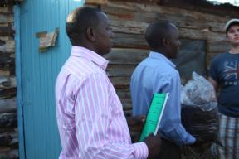

The COSDEP gave us our first taste of Kenyan hospitality. To me it seems that those in rural communities around the world are more open and prone to giving. Though we ran late, they generously welcomed us into their home and prepared a feast for us. They served us farm fresh salads, bananas, pineapple, potatoes, maize, chicken, and some red meat. They also served us tea. I was moved that these people would give us so much, when I knew that all that they had was hard earned. They put out their best and welcomed twenty strangers into their home, and I was impressed. It seemed like everywhere we went (aside from the tourist traps) that we were treated like family.
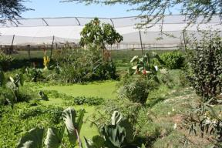
The Great Rift Valley was incredible. I didn’t know much about it coming in, but it is the only place on land that there is evidence of tectonic plate movement. This volcanic activity evidently creates good soil for agricultural activity. The area around Lake Navaisha was filled with greenhouses. There they produced flowers for export. A major issue the producers were generally ignoring was the draining of the lake. The greenhouses were primarily hydroponics. The Flamingo Cut Flowers for Export was the only establishment to attempt to recycle the water. They had impressive water treatment facilities. The managers of the site claimed that they only had a 30% evaporation loss, and could recycle 70% of the water, but those numbers seemed a little high to me. The water that ran through the plants was collected and transported underground to a lagoon. They had two ways of cleaning the water—artificial wetlands and mechanical removal. The plants in the artificial wetland were supposed to remove most of the extra chemicals like nitrogen. The mechanical removal was more complex. There was a holding tank where the used water was held. It was then moved through a machine that removed dissolved solids. One set of filters was supposed to remove excess nitrogen. The treated water was held in another large storage tank to be used on the flowers as needed.

It surprised me that so many companies could produce flowers where the natural vegetation was desert-like. The Kenyan transportation systems didn’t seem that good, but they could move the flowers to basically any part of the world within 48 hours, or quickly enough that they didn’t wilt or spoil. They also had a very precise growing cycle. A steady supply was grown for most of the year, but when demand increased around Valentine’s Day or Mother’s Day, they could have twice or three times as many flowers ready to be harvested at exactly the right moment. The Non-Government Organization that was trying to make the producers conserve water was a good idea, but I doubt that it will be very successful. They didn’t offer any economic incentives for conservation or punishments for being wasteful. The producers likely won’t install multi-million dollar water treatment centers unless they have to. The unfortunate reality is that like many places around the world, they may postpone doing anything until they run out of water, then wonder where and why all the water is gone.
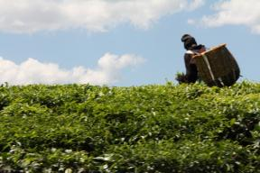
Perhaps the most interesting part of the trip was the tea production in Kericho. I got to see how the tea goes from the fields of Kenya to tea cups around the world. Each step I found fascinating. Being a developing country, the Kenyans don’t have much machinery but do have lots of people needing jobs, which is how they can afford to produce tea largely by hand picking the leaves. The tea plantations to me were reminiscent of the American cotton plantations or mining enterprises. The company employed the workers, educated their families, provided company houses, and sold them groceries at the company store. The huge fields of tea, as far as the eye could see, highlighted the contrasting views of production agriculture; instead of crop diversity, rotation, and minimal chemical use, the tea fields used lots of nitrogen—applied in huge quantities by plane—and grew year after year. Some of the tea plants were the original ones planted by the British in the early 1900’s, but they were being replaced by more genetically advanced and efficient plants.
After being picked, the leaves were sorted on the tables and then shipped to be processed. The factory we toured dried the tea and sold it at auctions around the country to be blended by another company. The tea started up a rail to upper level drying racks, where the natural convection reduced its moisture content by 17%. The tea was then chopped and allowed to ferment, with the exception of the green tea, which isn’t allowed to oxidize. As the black tea finishes curing, it is sent through a furnace that reduces the moisture content to 3%-5%. The furnaces are heated by eucalyptus wood. Eucalyptus trees are grown around the edges of the tea fields and are used because of their high heat and fast growing nature. The quality tea is shipped out, and the fines are turned into instant tea.
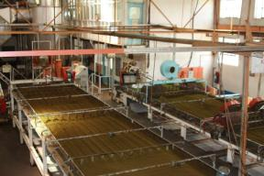
The Ketepa Tea Company was one of the companies that would purchase in bulk from a processing company. This one small plant, built in the 1930’s, exported over 9 million kilos of tea per year. Most of the tea produced in Kenya is for export. At the Ketepa plant, they combined tea from the two distinct kinds, East & West Rift Valley. Tea found west of the Rift Valley had dark, highly caffeinated characteristics and was cheaper. The tea found east of the Rift Valley was a higher quality, purer colored and better flavored tea. According to our guide it was due to the rocky nature of the soil in the east compared to the deeper soils of the west; he likened it to the characteristics imparted by the terrain on wine grapes as they grow. They bought six different distinct types to make the ideal blend for each of their markets; the Middle Eastern countries preferred a darker blend. They did custom packaging for each major buyer. An interesting machine took the blended tea and bagged, tagged, and boxed it all at once; this custom built machine was as good as or better than ones used by the tea giant, Lipton.
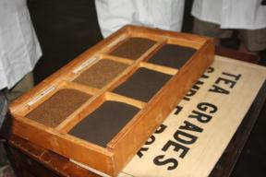
Would Kenya have become a world leader in tea production if they hadn’t been an English colony? I would assume not. Most often European colonization is looked upon in a negative light, yet this resulted in a relatively stable, highly lucrative industry for the Kenyan people. By specializing in one main crop, Kenya is able to compete on a global level. Maybe this should be a model for other developing countries. As far as tea is concerned, it can only be grown under the right set of circumstances. It must have a cool, moist climate and high altitudes that are found relatively few places in the world. A component of economics is that a firm should produce what it’s best at. Kenyans found a market for their product and specialized. They accommodated their consumers and became one of the few producers of the most widely consumed drink in the world.
We stayed for three days at the Manor House Agriculture Center. I learned so much there and really got a sense of what most of Kenya’s agriculture was like. The land had been donated by an English woman. The goal of the Manor House was to teach and promote sustainable agriculture. Most students studied for at least two years to earn a certificate. Students came from all over—from bordering countries like Uganda and Tanzania—to learn why sustainable agriculture was important and how to implement techniques. I participated in many agriculture activities. I drove a donkey to plow a field. I thought it was ironic and quite funny to see Kenyans talking on their cell phones while driving donkeys. Donkeys were used because oxen were too high profile and stolen frequently. We all helped make compost. The compost was made of carbon crops, manure, some completed compost (for introducing microbes to break it down), and kitchen waste or various other organic materials. Some compost needs ash to add potassium back to the soil.
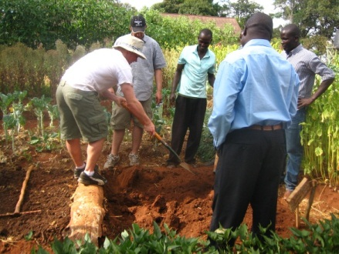
What I think sustainable agriculture should be is an efficient system that is continuous; that is, each enterprise should contribute to the continuation and betterment of another. Sustainable agriculture should make the most of scarce resources and provide food and fiber for the inhabitants of the land. The MHAC was nearly an efficient system. With the exception of some goods like shoes, or gasoline, or cars, they basically grew everything they needed. What they sold at market as cash crops paid for all of those things. The crops they grew fed themselves and their livestock. The livestock provided milk and protein. The waste from the animals went back to the crops to make them grow better. I hadn’t seen a biogas setup before. That is a great idea, because the methane that is captured is used for heating or electricity and the organic matter is turned back into the soil. The double digging technique was quite labor intensive but effective for small scale agriculture and well suited to the environment. This technique broke up the hardpan and clayey subsoil and mixed compost and nutrients into the topsoil. They conducted research to compare it to the traditional methods of planting, and the double digging method allowed for further root penetration and a greater density of plants to be grown per hectare. A bed only needed double digging once every five years. Once a bed was dug, they used sticks line up holes and evenly space the seeds. This again allowed for more plants to be grown in a smaller space.

On one evening, Urzula took us to look at the soil horizon. We saw a typical pattern down about 5 feet, but then it looked as if another horizon was starting again. I attributed this to the volcanic activity in the area. Polly showed us her farm one evening. She had horses, which I didn’t see anywhere else in Kenya. She also had a camel that we were allowed to ride. They had problems to deal with there that I would have never imagined, like having to have a high electric fence to keep monkeys out of the banana trees. Polly had taken on several Manor House graduates to help her run the place. On the way out of Kitale, we stopped at an agroforestry center. The land was donated by Swedes. This center used sustainable techniques and was trying to restore native trees to the area. Some trees they sold for cost and some they gave away. The trees all had interesting “medicinal” and traditional uses according to our guide, ranging from cures for a stomach ache to helping a man’s libido.
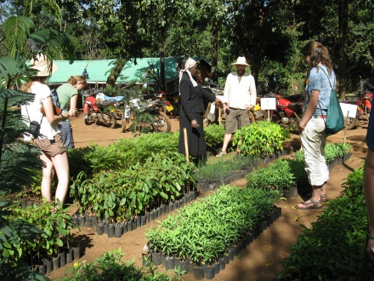
There are many challenges for the future of Kenyan agriculture, but I feel that they should be able to overcome them. Perhaps one of the biggest that they face is quite similar to the problem here in America—the social stigma that “if you can’t be anything else, you can be a farmer.” Agriculture is one of the most important of jobs, because everyone has to eat. Yet in so many places it is looked down upon. I think it is truly empowering to grow your own food; you aren’t dependent on anyone but yourself. When I think about Africa in general, and all of its problems, I think about relief workers who give aid. This is good, and often needed, but with programs like the sustainable agriculture centers, people are taught to fend for themselves rather than just receive handouts. If people take handouts, as soon as the charity is gone they are back in the same predicament as before. When I asked the director of Manor House how quickly word was spread about their mission, he simply replied, “Quite slowly.” I don’t know how they should get their message out more quickly, but if they could advertise somehow it would only help. These programs have so much potential to make real changes and the Kenyans seem interested in improving their conditions.

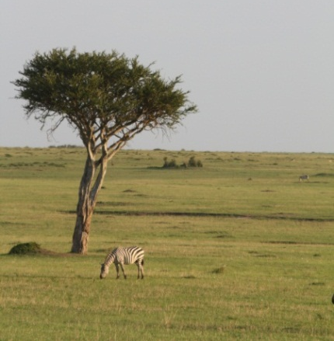

The safari through Masaai Mara National Park was incredible. Though not directly an agricultural product, it was an interesting part of Kenyan society and economy as a form of ecotourism, it showcases a natural resource. The terrain looked like South Dakota and the park reminded me of Yellowstone. The big game was unbelievable. I had no idea that there would be that many animals all together. The zebras, wildebeests, and gazelles all congregated together. To see lions and cheetahs on fresh kills was completely unexpected and amazing.
It seemed that the tourism industry was similar the world over; if you aren’t careful, someone will take advantage of you. The drivers only took us into the park one of the three days we paid for park entrance. I also paid 1000 shillings to see what I thought were Masaai warriors and villagers dance. When I returned, my friend who had lived with the actual Masaai for two years, told me that he was 95% certain they were Kikuyu, the largest tribe in Kenya. The native people’s story was quite interesting though. The Masaai faced the same problems as cattle producers around the world face—loss of rangelands and being pushed to confinement. It is important to protect what we have left of wild and exotic places in the world. The Masaai are fighting for theirs, and so far their government hasn’t stopped them from continuing their traditional way of life.

As we traveled, I saw a clear picture of life in Kenya. In the good parts of Nairobi, there were some nice houses and cars, but on the drives through the country I saw many small shops, rural villages with garbage on the streets and tiny houses made of tin roofing. Men on the streets were lounging, probably because they didn’t have a job. Wherever we went we were hounded by street salesmen and women because they knew we had money. While we generally avoided the really poor parts for safety reasons, on the extra day we made it middle of Nairobi. It was entirely different from the rest of town. People were everywhere. Traffic was horrendous. Women filled the marketplaces, everyone trading. When we went to Kitale and it was remote enough that the children hadn’t seen white people before, I was shocked. I won’t ever forget when the little boy looked up and saw the bus full of white people and yelled “Muzunga!” Though there was much poverty, the people weren’t poor in nature. They were a happy and kind people who put on their best for us.
Overall I had an amazing trip. I learned so much about agricultural producers halfway around the world. It was an incredible trip to introduce me to international travels and I hope to be able to go on trips like this in the future. I now know why the University of Wyoming supports sustainable agriculture here in Wyoming.

